**WEEK-12**

**Definition:-**

Oracle creates a memory area, known as the **context area**, for processing an SQL statement, which contains all the information needed for processing the statement. A **cursor**is a pointer to this context area.

There are two types of cursors −

1. Implicit cursors
2. Explicit cursors

**Implicit Cursors**

Implicit cursors are automatically created by Oracle whenever an SQL statement is executed, when there is no explicit cursor for the statement. Programmers cannot control the implicit cursors and the information in it. If you use an implicit cursor, Oracle will perform the open, fetches, and close for you automatically. Implicit cursors are used in statements that return only one row.

In PL/SQL, you can refer to the most recent implicit cursor as the SQL cursor, which always having some attributes. The following table provides the description of the most used attributes.

|  |  |
| --- | --- |
| **Attribute** | **Description** |
|  |  |
| %ROWCOUNT | The number of rows processed by a SQL statement. |
| %FOUND | TRUE if at least one row was processed. |
| %NOTFOUND | TRUE if no rows were processed. |
| %ISOPEN | TRUE if cursor is open or FALSE if cursor has not been opened or has been closed. Only used with explicit cursors. Always returns FALSE for implicit cursors, because Oracle closes the SQL cursor automatically after executing its associated SQL statement. |

**Explicit cursors**

Explicit cursors are programmer-defined cursors for gaining more control over the context area. An explicit cursor should be defined in the declaration section of the PL/SQL Block. It is created on a SELECT Statement which returns more than one row.

**The syntax for creating an explicit cursor is**

CURSOR cursor_name IS select_statement;

Working with an explicit cursor includes the following steps:-

1. Declaring the cursor for initializing the memory
2. Opening the cursor for allocating the memory
3. Fetching the cursor for retrieving the data
4. Closing the cursor to release the allocated memory

***Declaring the Cursor***

Declaring the cursor defines the cursor with a name and the associated SELECT statement.

**Syntax:**

CURSOR cursor_name IS Select_statement;

For example:

CURSOR c_customers IS SELECT id, name, address FROM customers;

***Opening the Cursor***

Opening the cursor allocates the memory for the cursor and makes it ready for fetching the rows returned by the SQL statement into it.

**Syntax:**

OPEN cursor_name;

For example, we will open the above defined cursor as follows:

OPEN c_customers;

***Fetching the Cursor***

Fetching the cursor involves accessing one row at a time.

**Syntax:**

FETCH cursor_name INTO cursor_variable(s);

For example, we will fetch rows from the above-opened cursor as follows:

FETCH c_customers INTO c_id, c_name, c_addr;

***Closing the Cursor***

Closing the cursor means releasing the allocated memory.

**Syntax:**

CLOSE cursor_name;

For example, we will close the above-opened cursor as follows:

CLOSE c_customers;

**1)** **To write an Implicit Cursor for updating the salary of each customer by 500 and determine the number of rows affected.**

**STEP 1: Creation of customers table**

SQL> create table customers(id number,name varchar2(10),age number,location varchar2(15),salary number);

Table created.

**STEP 2: Inserting values in customers table**

SQL> insert into customers values (1,'Ramesh',32,'Hyderabad',15000);

1 row created.

SQL> insert into customers values (2,'Rahul',29,'Mumbai',13000);

1 row created.

SQL> insert into customers values (3,'Ranjith',23,'Chennai',9000);

1 row created.

SQL> insert into customers values (4,'Ram cahran',25,'Banglore',17000);

1 row created.

SQL> insert into customers values (5,'Rajesh',28,'Mysore',16000);

1 row created.

**STEP 3: Display the records of customer details**

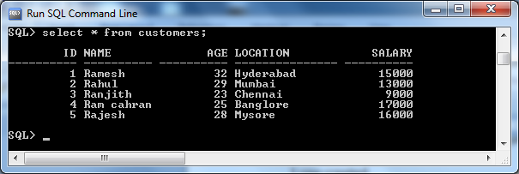

**STEP 4:**

**The following program will update the table and increase the salary of each customer by 500 and use the SQL%ROWCOUNT attribute to determine the number of rows affected.**

DECLARE

total_rows number(2);

BEGIN

UPDATE customers

SET salary = salary + 500;

IF sql%notfound THEN

dbms_output.put_line('no customers selected');

ELSIF sql%found THEN

total_rows := sql%rowcount;

dbms_output.put_line( total_rows || ' customers selected ');

END IF;

END;

/

5 customers selected

PL/SQL procedure successfully completed.

**STEP 5: Display the records of customer details**

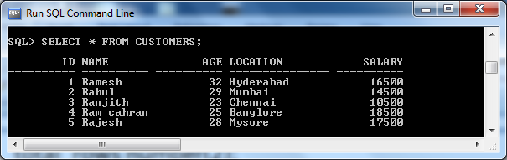

**2)** **To write an Implicit Cursor for displaying the required customer details.**

DECLARE

var_id number;

var_name varchar2(10);

var_age number;

var_location varchar2(10);

var_salary number;

req_id number:=&req_id;

BEGIN

SELECT id,name,age,location,salary

INTO var_id, var_name, var_age, var_location, var_salary

FROM customers

WHERE id=req_id;

dbms_output.put_line ('Customer details regarding to required id '|| chr(10)||var_id||chr(9)||var_name|| chr(9)||var_age|| chr(9)|| var_location|| chr(9)|| var_salary);

EXCEPTION

WHEN NO_DATA_FOUND THEN

dbms_output.put_line ('No Customer details regarding to required id ');

END;

/

Enter value for req_id: 5

old 7: req_id number:=&req_id;

new 7: req_id number:=5;

Customer details regarding to required id

5 Rajesh 28 Mysore 16000

PL/SQL procedure successfully completed.

SQL> /

Enter value for req_id: 6

old 7: req_id number:=&req_id;

new 7: req_id number:=6;

No Customer details regarding to required id

PL/SQL procedure successfully completed.

**3)** **To write an Explicit Cursor for displaying the customer details whose id is less than 5.**

DECLARE

c_id customers.id%type;

c_name customers.name%type;

c_location customers.location%type;

--declaring a cursor

CURSOR c_customers is

SELECT id, name, location FROM customers WHERE id<5;

BEGIN

--opening a cursor

OPEN c_customers;

LOOP

--fetching records from a cursor

FETCH c_customers into c_id, c_name, c_location;

--testing exit conditions

EXIT WHEN c_customers%notfound;

dbms_output.put_line(c_id || chr(9) || c_name || chr(9) || c_location);

END LOOP;

--closing the cursor

CLOSE c_customers;

END;

/

1 Ramesh Hyderabad

2 Rahul Mumbai

3 Ranjith Chennai

4 Ram cahran Banglore

PL/SQL procedure successfully completed.PL/SQL procedure successfully completed.